# **Active Data-Base**

Conventional data-base 🡪 Passive data-base  
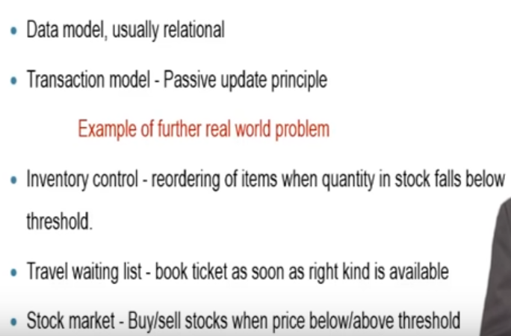

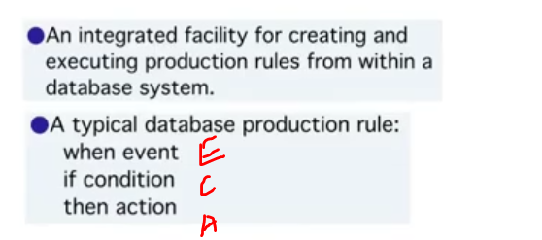

Any data-base that supports triggers are known as active data-base.

Active data-bases (i.e triggers) should automatically trigger insisting on updating all the values to the user in-case specific event occurs.

Classification of active and passive data-bases primarily depends upon the rule format.

# **Uses of Active Data-Base**

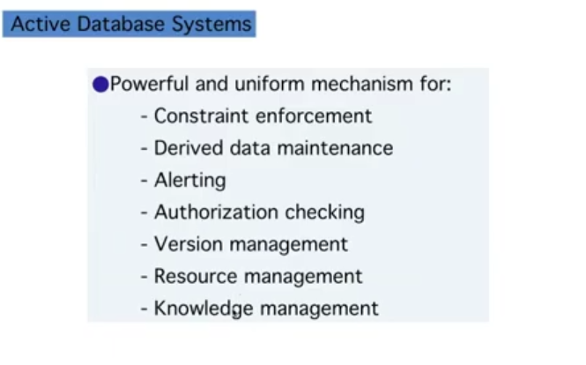

# **Event-Condition-Action**

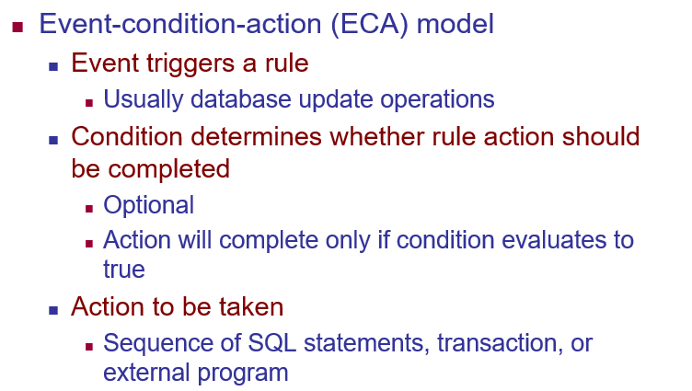

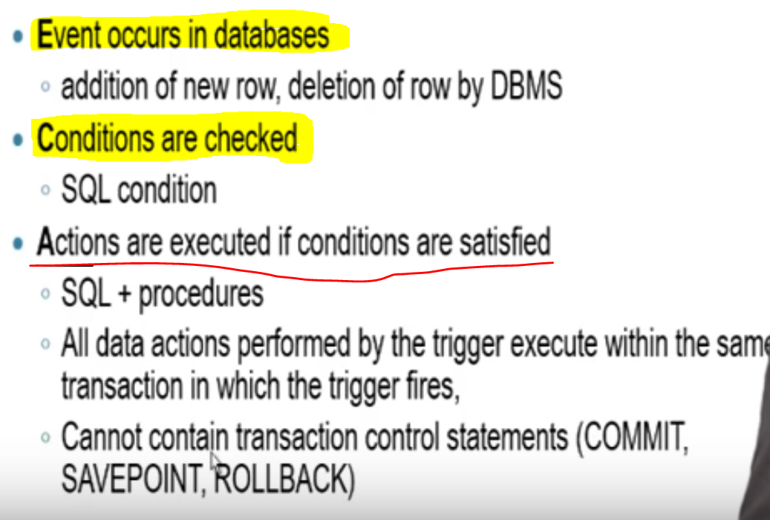

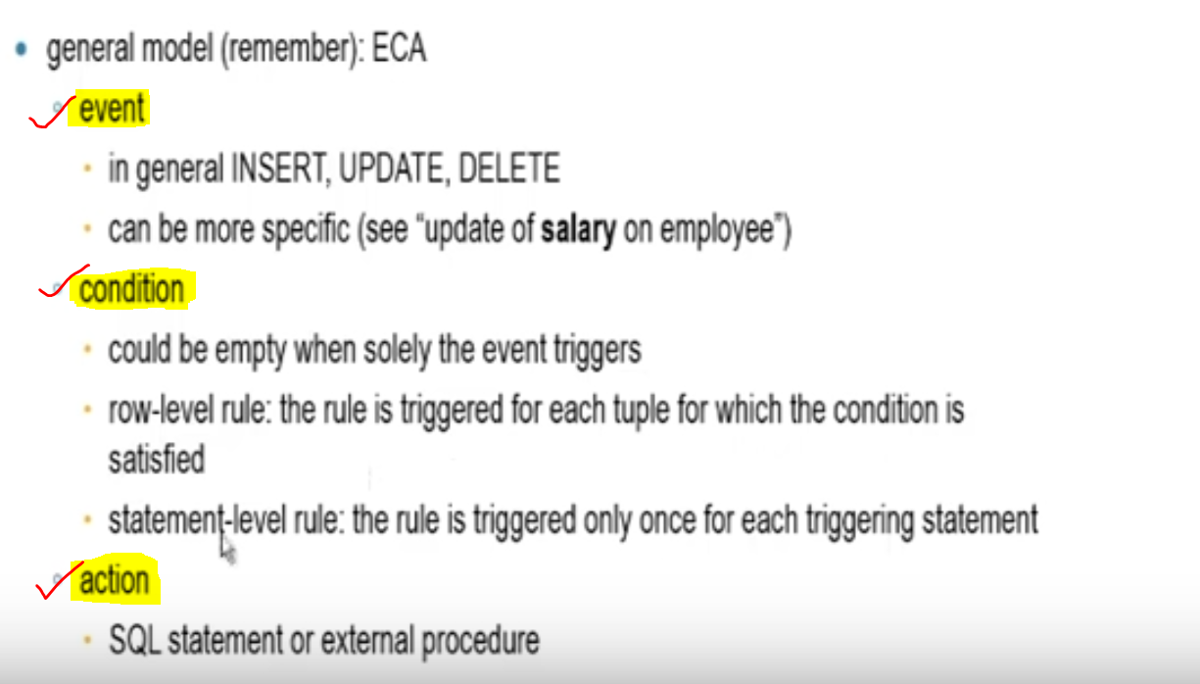

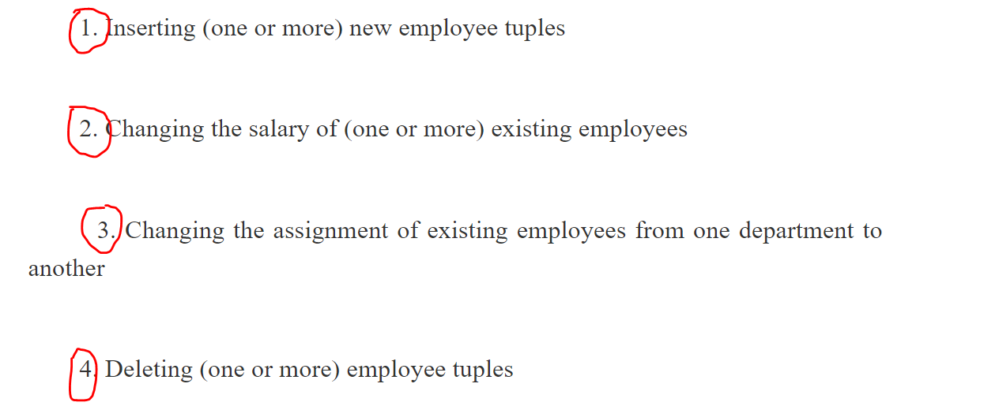

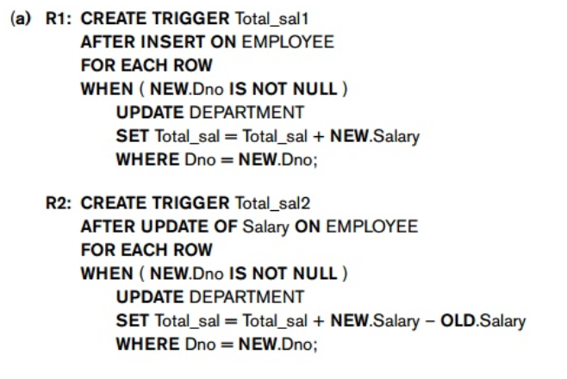  
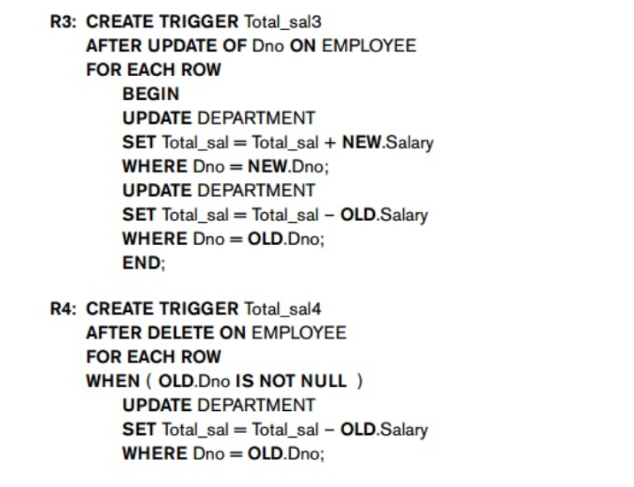

**R1 🡪** INSERT operation When a new employee is added.  
**R2 🡪** UPDATE operation When an existing employ salary is changed.  
**R3 🡪** When an employee goes from one department to another department.  
*Rule R3 is triggered by an update to the* **Dno** *attribute of EMPLOYEE, which signifies changing an employee’s assign-ment from one department to another. There is no condition to check in R3, so the action is executed whenever the triggering event occurs. The action updates both the old department and new department of the reassigned employees by adding their salary to* **Total_sal** *of their new department and subtracting their salary from* **Total_sal** *of their old department. Note that this should work even if the value of* **D_no** *is NULL, because in this case no department will be selected for the rule action*.  
**R4 🡪** When an employee goes from one department to another department.  
By default that specific employee details will be removed.  
So in R4, we are subtracting the **Total_sal** from the older department table.  
After this we R1 trigger will work.

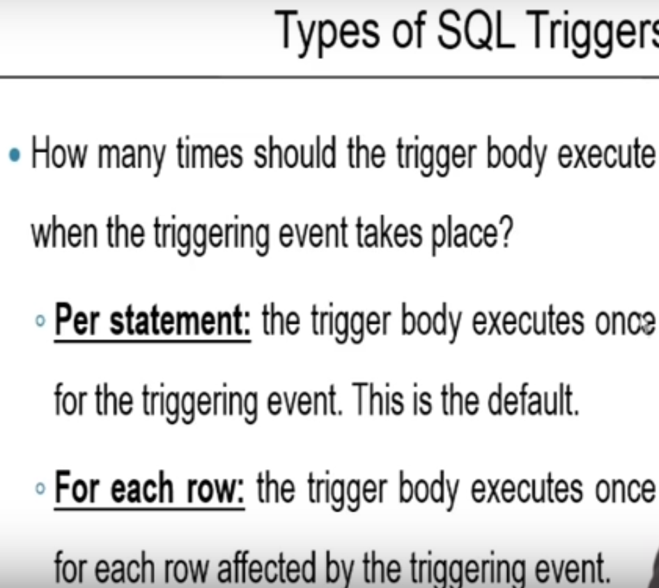

**Example-1**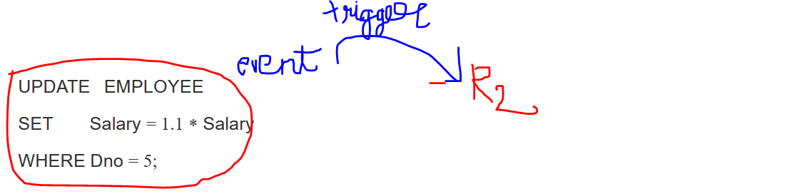  
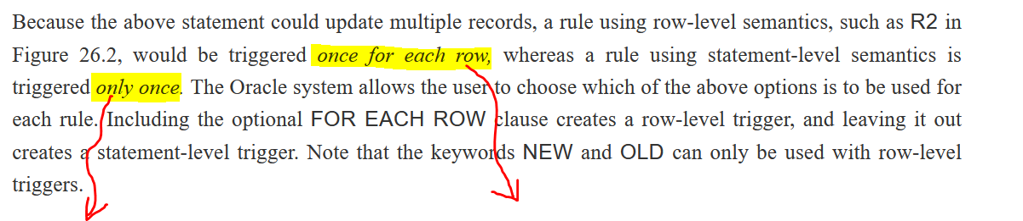Statement-level trigger Row-level trigger

**Example-2**

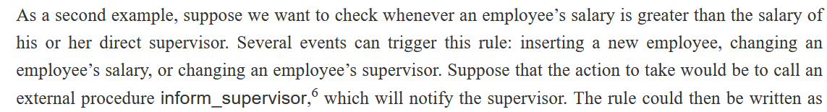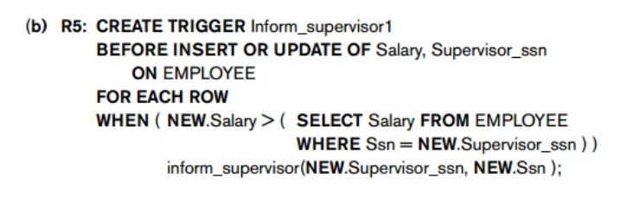

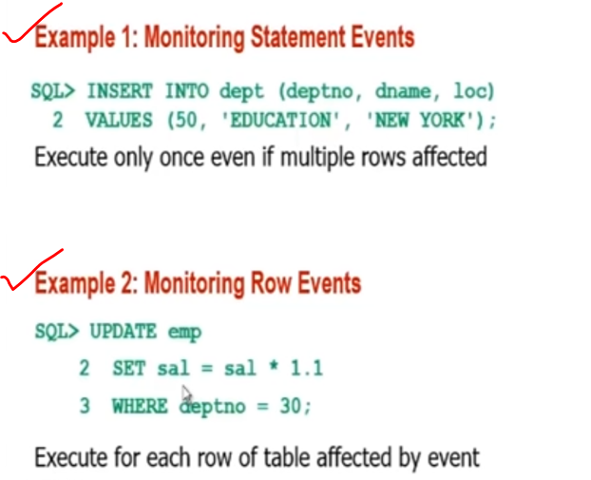 **Trigger**

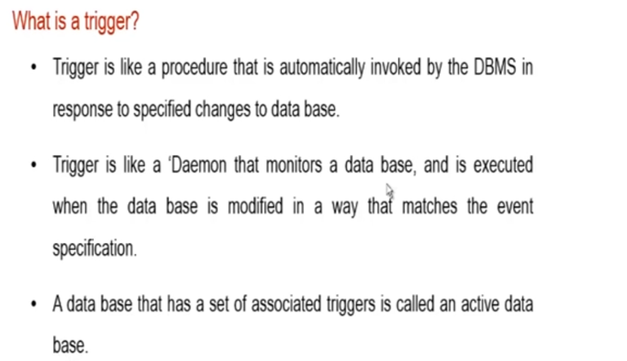

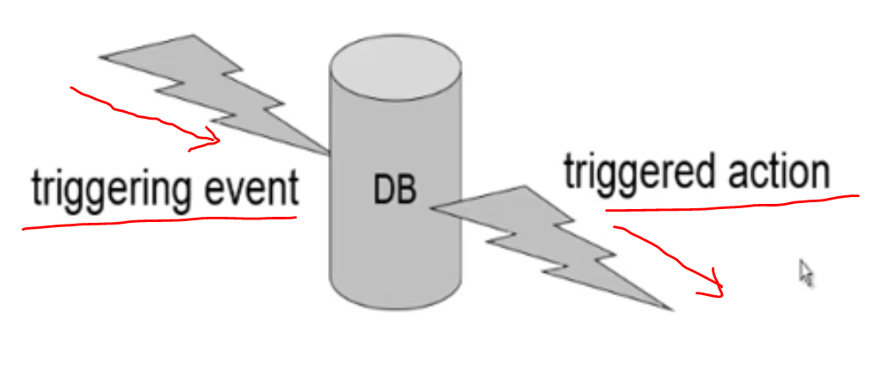

Syntax of a trigger   
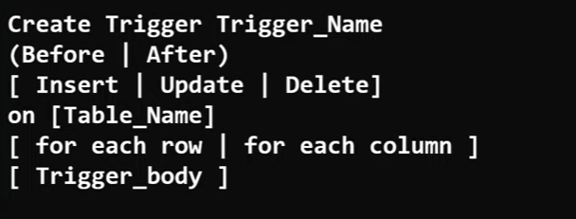

new 🡪 used to specify the row that is getting affected.

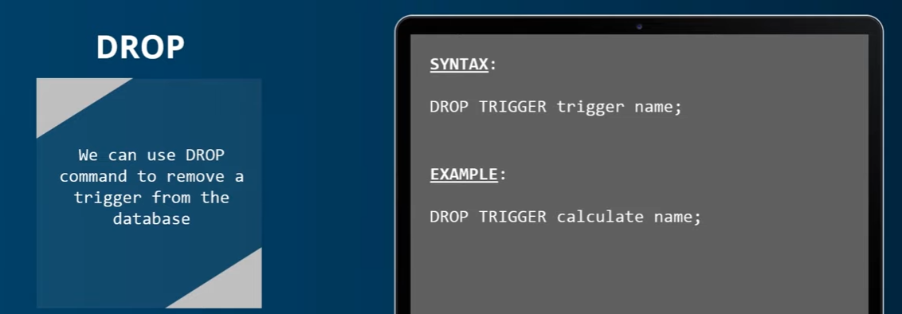

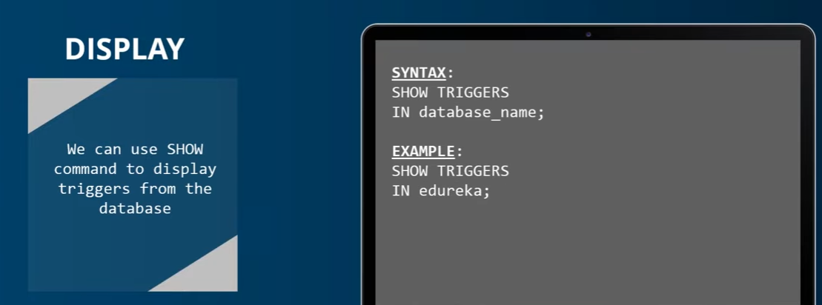

before insert trigger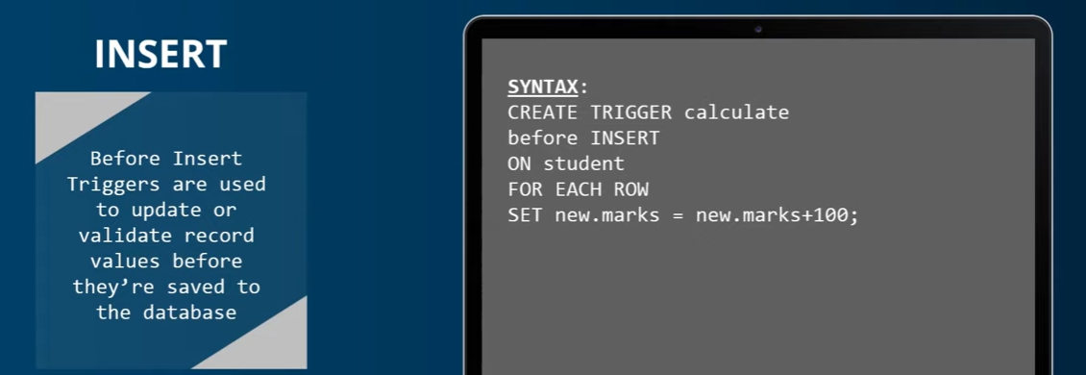

As soon as a new student is added, 100 marks will be added to their present mark.

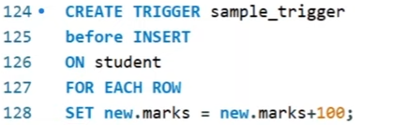  
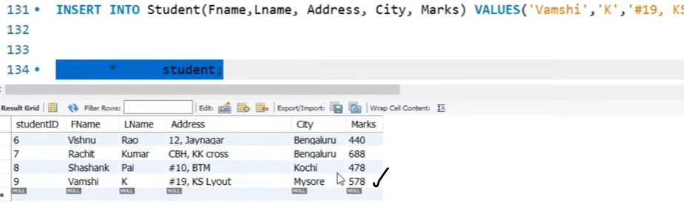

Initial Vamshi mark 🡪 478  
After inserting the value into the table, Vamshi mark 🡪 578

# **Design and Implementation Issues for Active Databases**

**Issue-1**  
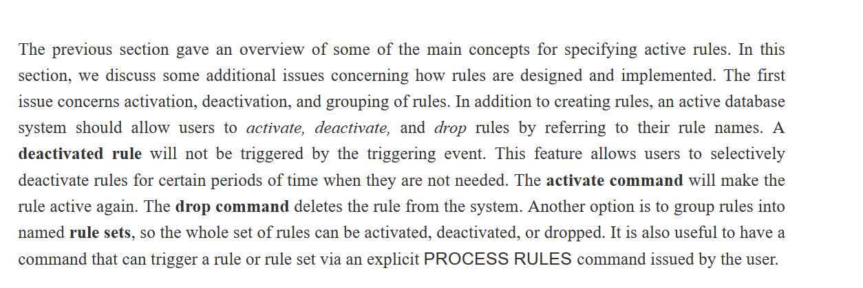

**Issue-2**  
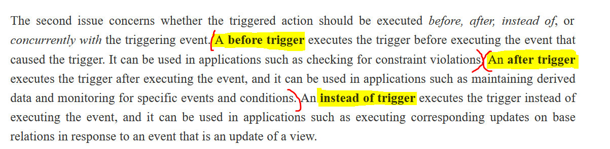

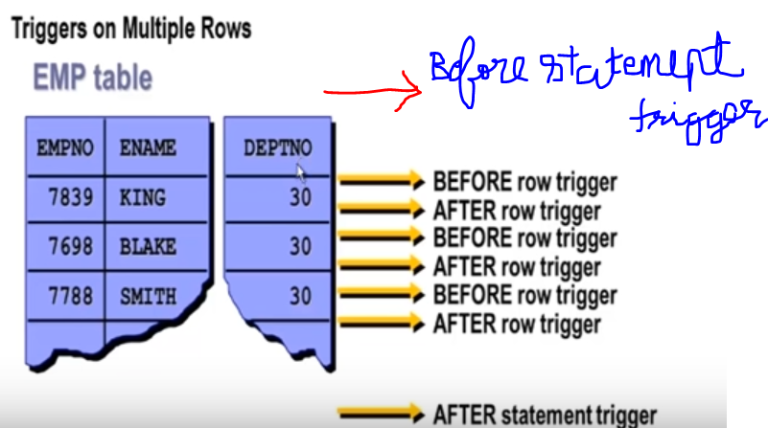

**Issue-3**

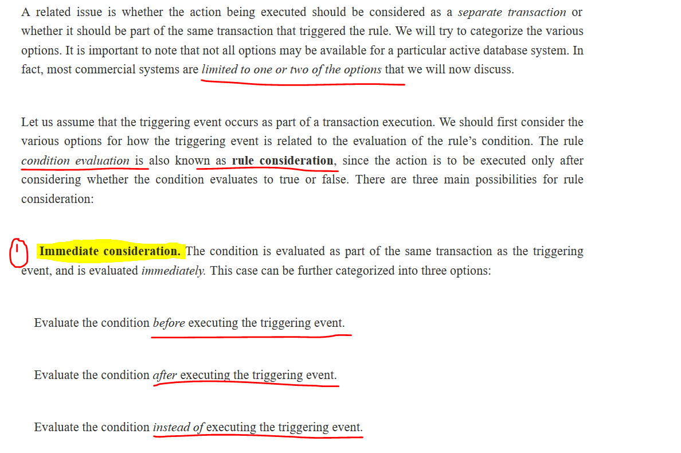  
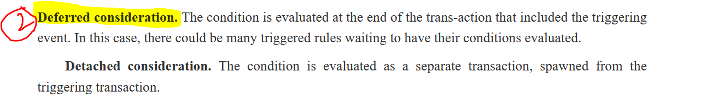

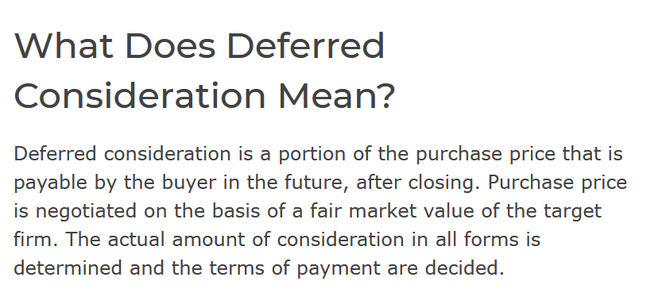

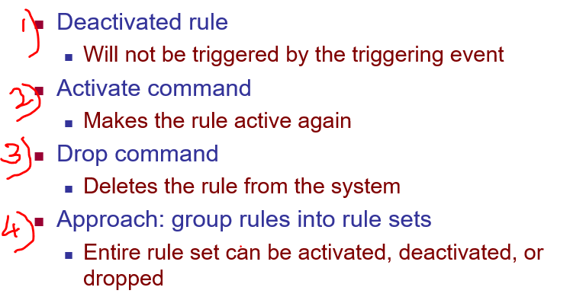  
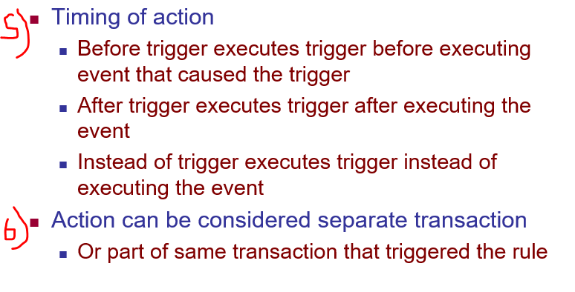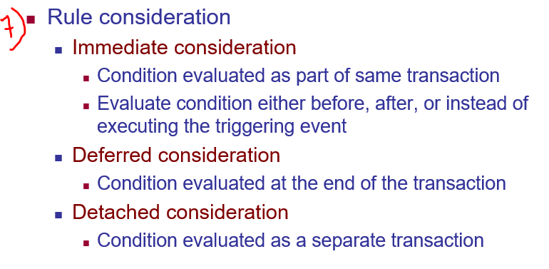

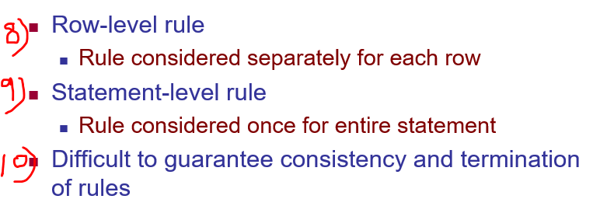

# **Examples of Statement-Level Active Rules in STARBURST**

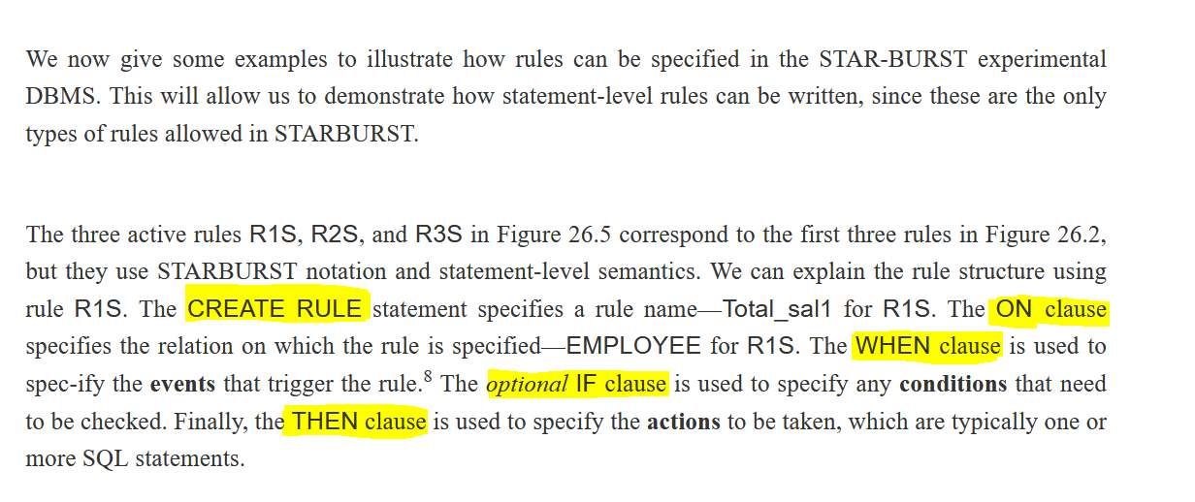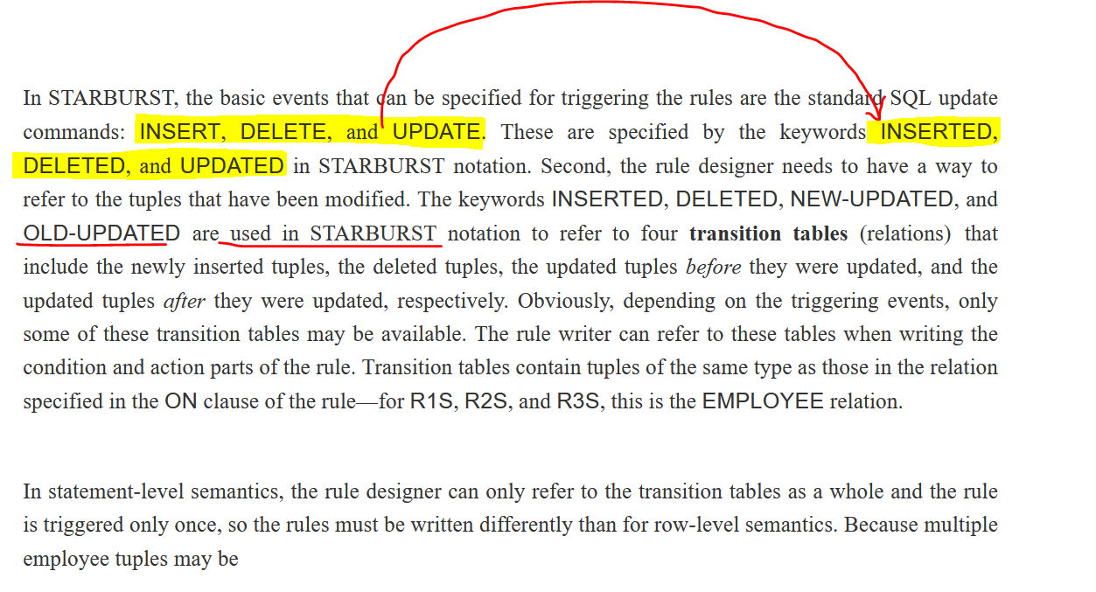

**R1 🡪** INSERT operation When a new employee is added.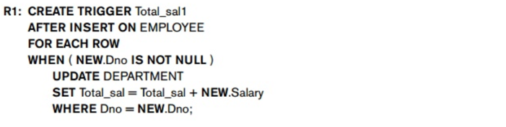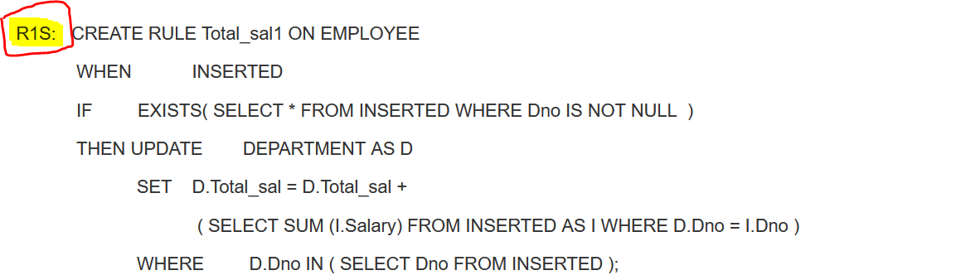

**R2 🡪** UPDATE operation When an existing employ salary is changed.

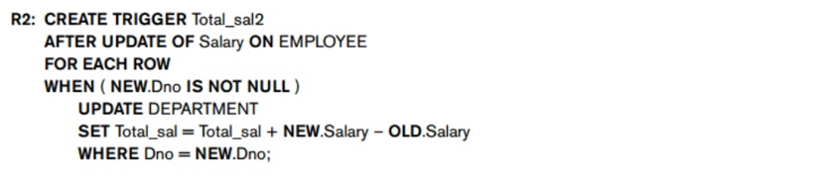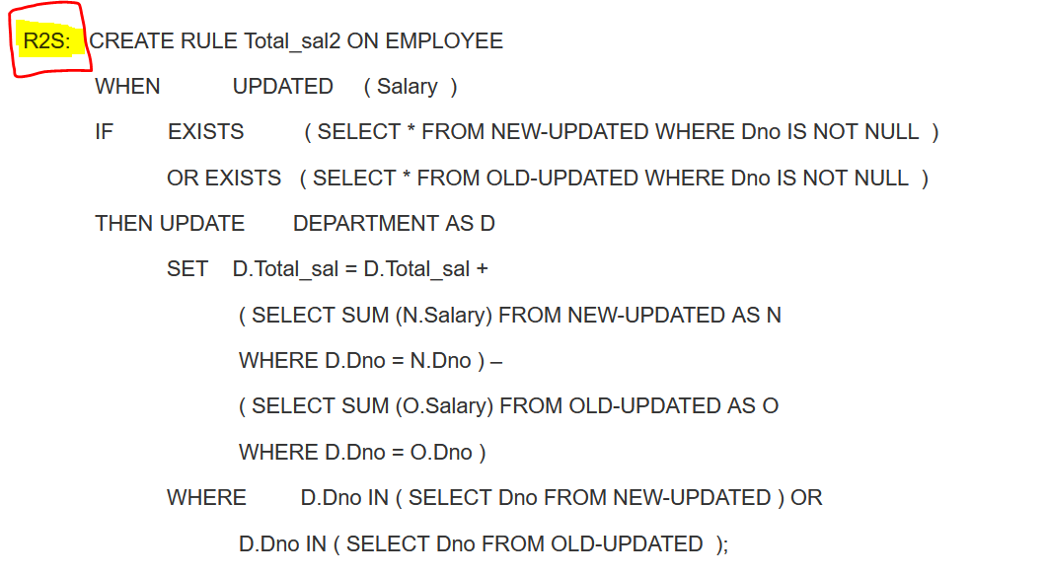

**R3 🡪** When an employee goes from one department to another department.  
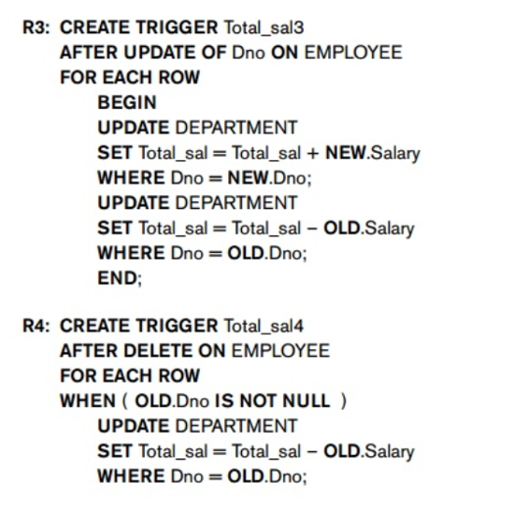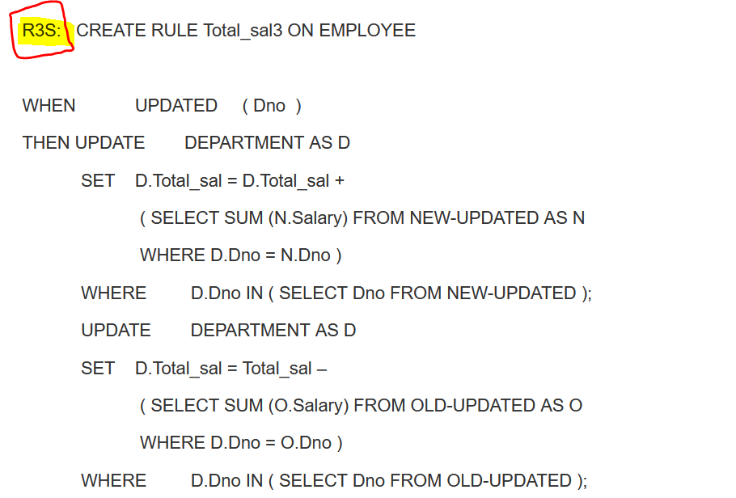

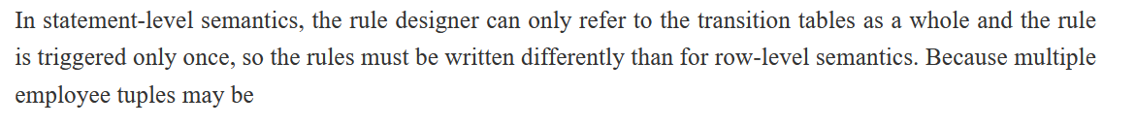  
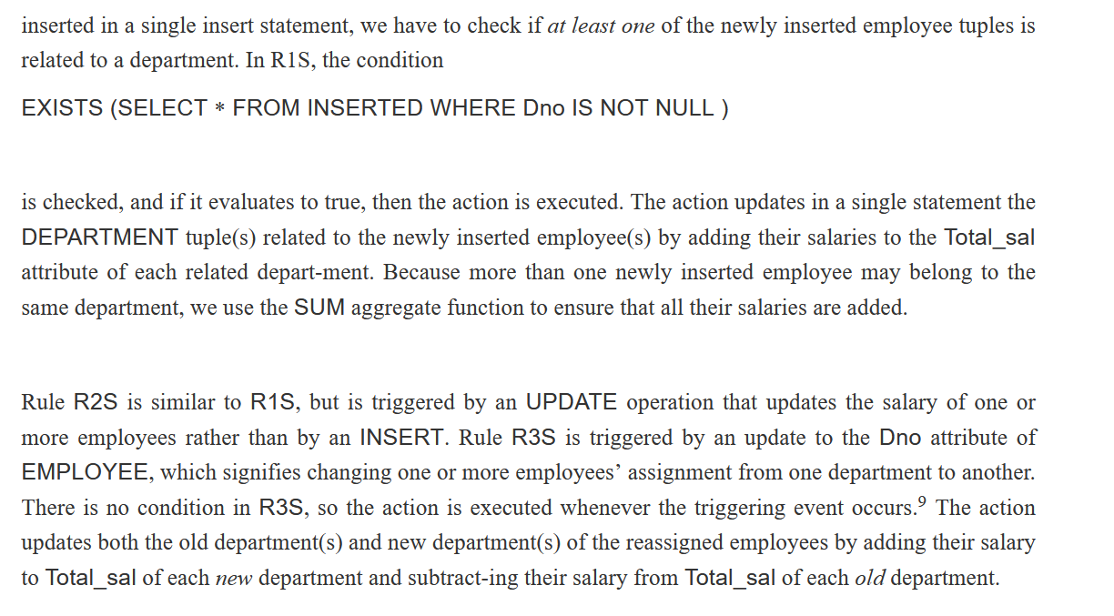

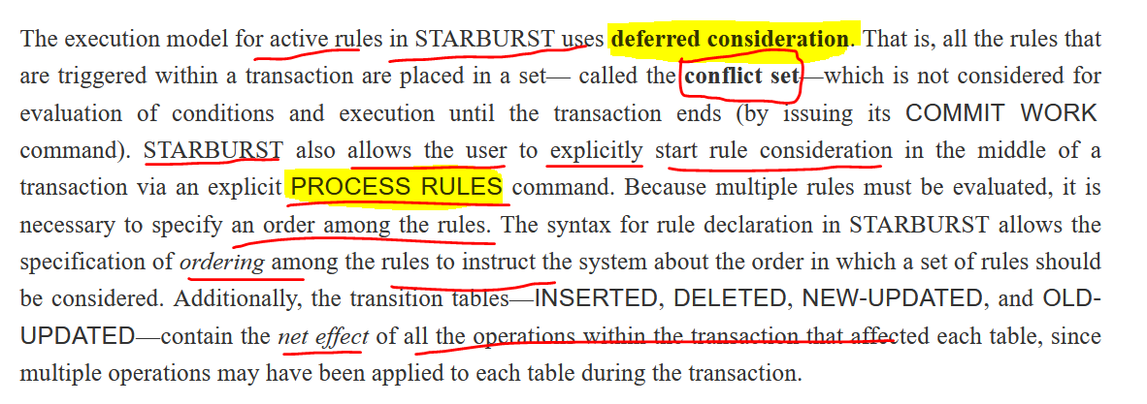

# **Potential Applications for Active Data-bases**

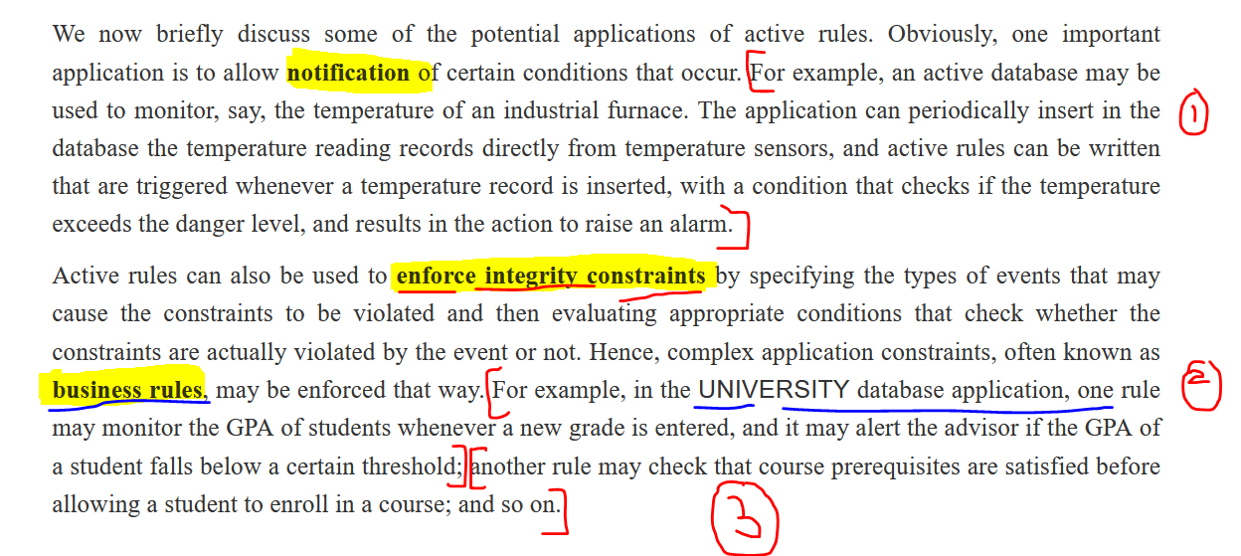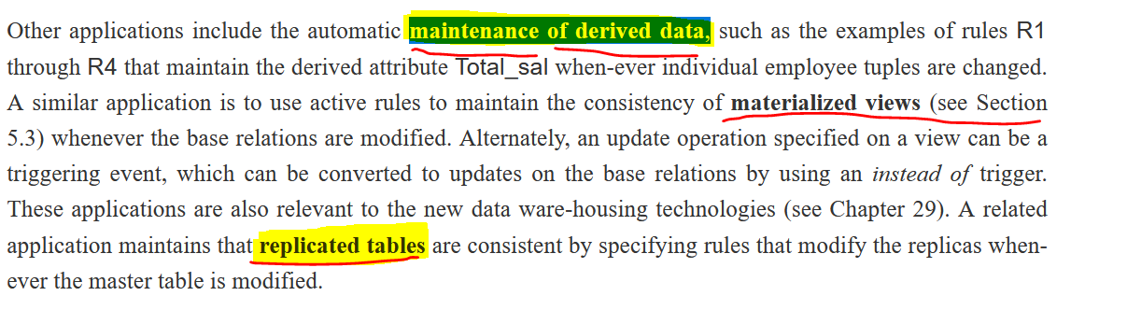

Reference

<https://www.youtube.com/watch?v=f6VWSlnHGCE>

<https://www.brainkart.com/article/Active-Database-Concepts-and-Triggers_11601/>